Netra

Metrics for Brand Prominence in Video

Frame-Level Metrics

* Size
  + Width*Height
* Prominence
  + Size of Brand within each Panel
    - Panel sizes are customizable
  + Size is scaled by weights and confidence
    - Weights for each panel are customizable
    - Confidence from Netra algorithm
    - Default panel sizes and weights:

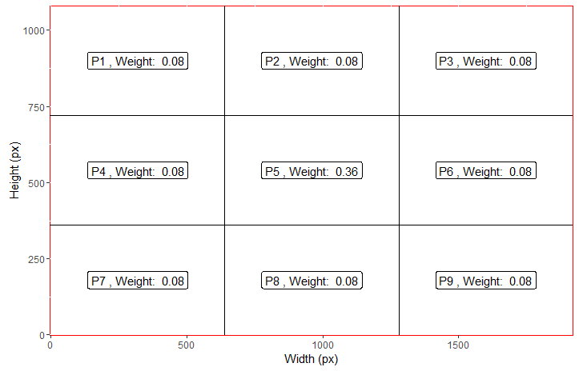

* + - Example of Prominence



*BRAND*

**A4 A5**

**A7 A8**

* + - Prominence ranges from 0-100
      * 100 means that the brand takes up the whole screen with 100% confidence

Program-Level Metrics

* For each brand:
  + Total prominence over the course of the program
  + Total time on screen